**SYMBIOSIS INSTITUTE OF TECHNOLOGY**

**PROGRAMMING PARADIGMS**

**LAB ASSIGNMENT 4**

**FUNCTIONS USING PYTHON**

**NAME:HARSH SACHIN CHANDEKAR**

**PRN:19070122066**

**CLASS:CS A**

**DATE:08/09/2020**

1. Write a Python program to make a calculator using Functions.
2. Print the reverse of given integer number using function.
3. Write a function is_prime() that returns 1 if the argument passed to it as a prime number and 0 otherwise.
4. Write a function that accepts an integer between 1 to 12 to represent the month number and displays the corresponding month of the year.

Write a function that accepts three integers and returns True if they are sorted and false if they are not sorted

**CODE**

import math

def calculator(a,op,b):

if(op=='+'):

result=a+b

elif(op=='-'):

result=a-b

elif(op=='*'):

result=a*b

elif(op=='/'):

result=a/b

elif(op=='%'):

result=a%b

return result

def scificalci():

n=int(input("enter your choice\n1.sin function\n2.cos function\n3.tan function\n4.exponential power"))

if(n==1):

a=float(input("\nenter angle in degrees\n"))

rad=(180/math.pi)*a

print("sin(",a,")=",math.sin(math.radians(a)))

if(n==2):

a=float(input("\nenter angle in degrees\n"))

rad=(180/math.pi)*a

print("cos(",a,")=",math.cos(math.radian(a)))

if(n==3):

a=float(input("\nenter angle in degrees\n"))

rad=(180/math.pi)*a

print("tan(",a,")=",math.tan(math.radian(a)))

if(n==4):

a=int(input("\nenter exponent of e (e^?)\n"))

print("the value is ")

print(math.exp(a))

def reverse(n):

rev=0

while(n>0):

rem=n%10

rev=(rev*10)+rem

n=n//10

print("entetr positive number")

print("reverse is",rev)

def prime(n):

flag=0

if(n==0 or n==1):

print("not prime")

else:

for i in range(2,n//2):

if n%i==0:

flag=flag+1

if flag!=0:

return False

else:

return True

def month(n):

m=['january','february','march','april','may','june','july','august','september','october','november','december']

print("the month is",m[n-1])

return 0

def number(a,b,c):

if(a<b and b<c):

return True

else:

return False

if (a>b and b>c):

return True

else:

return False

print("1.calculator \n2.scientific calculator\n3.reverse\n4.prime check\n5.month number\n6.number sort")

x=int(input())

if x==1:

print("1. calculator")

a=float(input("enter first number "))

op=input("enter operation")

b=float(input("enter second number"))

r=calculator(a,op,b)

print("the result is ",r)

elif x==2:

print("scientific calculator")

scificalci()

elif x==3:

a=int(input("enter number to be reversed"))

reverse(a)

elif x==4:

a=int(input("prime check number"))

x=prime(a)

print(x)

elif x==5:

n=int(input("enter month number"))

month(n)

elif x==6:

a=int(input("enter 3 numbers"))

b=int(input())

c=int(input())

op=number(a,b,c)

print(op)

else:

print("wrong output")

**OUTPUT SCREENS**

**MENU**

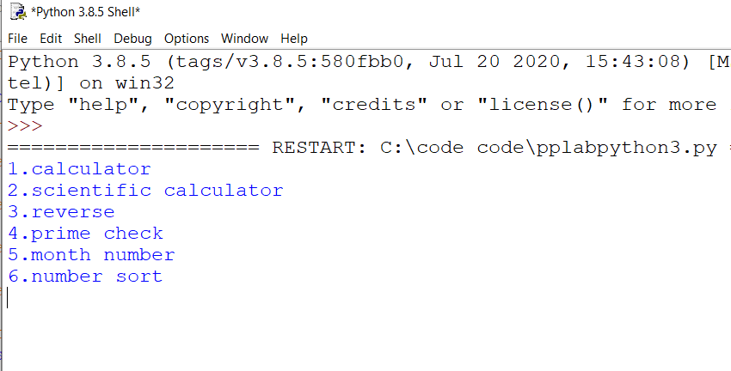

Normal calculator(we can input decimal as well as negative)

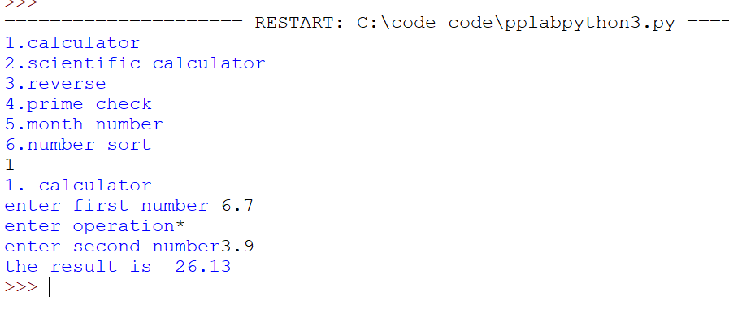

Scientific calculator using sin function

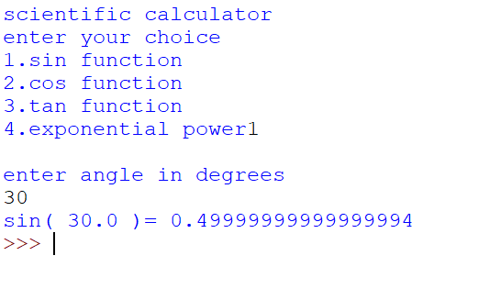

Representation of cos function

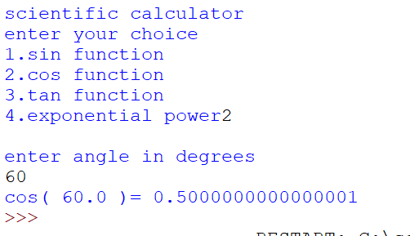

Tan function

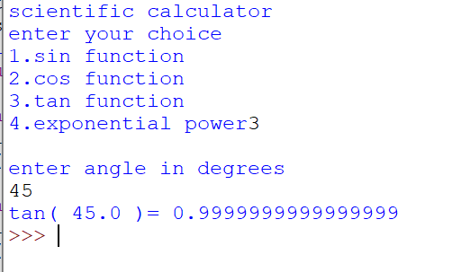

Power of exponent(can take decimal as well as negative power)

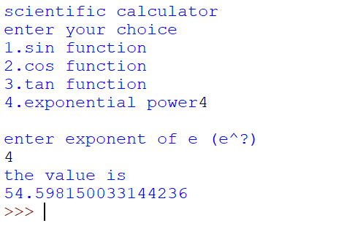

Reverse of a number upto capacity of int

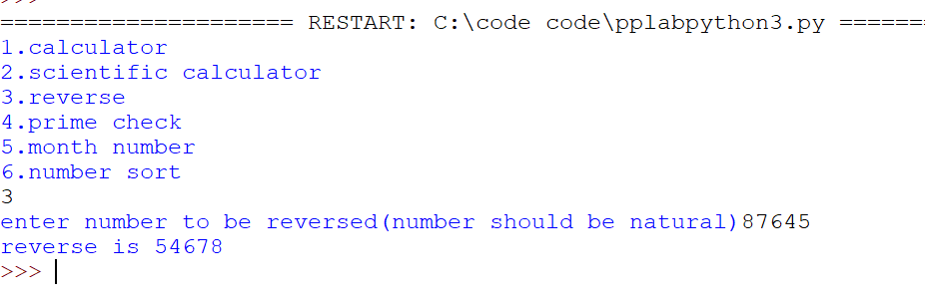

True case for prime number checking

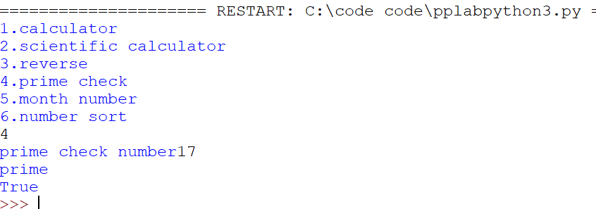

Boundary conditions checked for 0 and 1

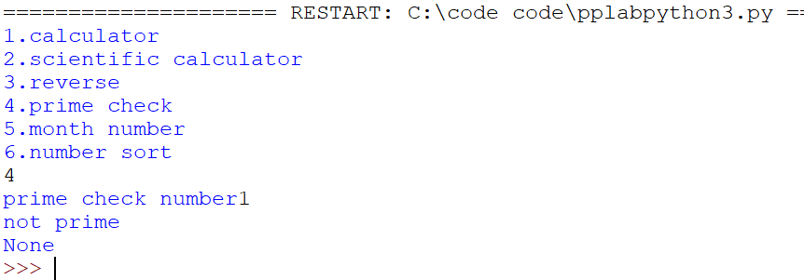

Month using index slicing in list

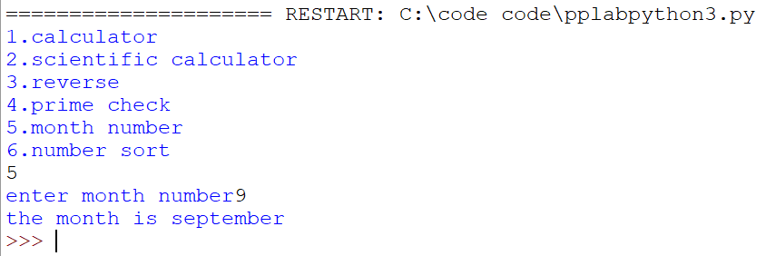

To check whether list is sorted or not

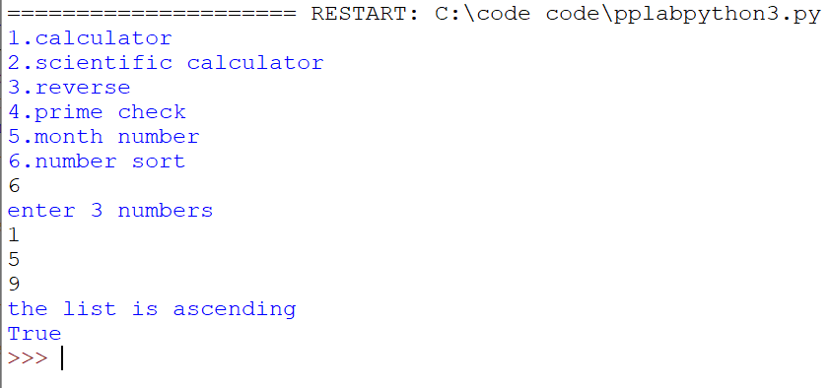

Unsorted list

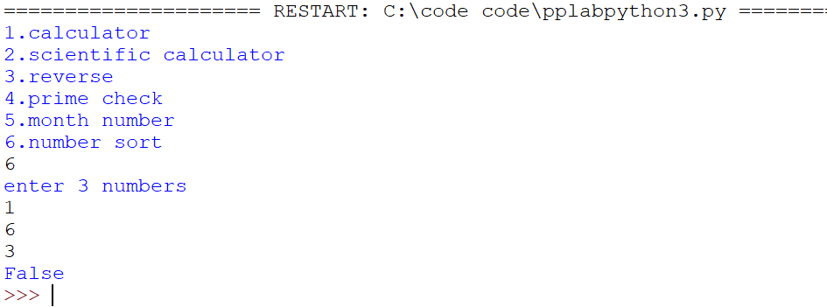

**Thankyou!**